CERTIFIED PUBLIC WORKS MANAGER (CPWM) - REQUIREMENTS
Statutory reference - N.J.S.A. 40A:9-154.6a et seq.
What are the requirements to obtain the CPWM certification? Besides the certification exam, there are several other means by which individuals can obtain this certification, all to be covered herein:
Certification Exam Requirements
- Minimum requirements for all applicants are 21 years of age, person of good moral character, and HS. diploma or equivalent.
- Completion of the Rutgers’ Center for Government Services CPWM program. This is a nine-course program that is entirely under the auspices of Rutgers. The Division has no approval role in these classes. In the exam application we simply need proof from Rutgers that the program was completed (program diploma, nine class certificates, or transcript from Rutgers showing completion of the nine classes with a score of at least 80 to pass each course.
  - Management Tasks, Responsibilities, and Practices
  - Managing and Developing Human Resources
  - Public Relations
  - Operations Resource Management
  - Management Accountability
  - Municipal Planning and Urban Development
  - Local Government in New Jersey
  - Municipal Budget Process
  - Public Works Purchasing
- Five years within the last 10 years at the time of the application, of public works management (not management in another field or business) experience. This is defined as 50% of the person's work time is spent in daily, direct supervision of public works’ duties. The person's title does not matter; it's the actual work that they are doing. An applicant might have a laborer title, but if they can demonstrate that they perform supervisory/management duties daily, their application will be accepted. We do not require them to be in charge of the whole public works department. If they are involved in management of one segment, such as recycling, grounds maintenance, fleet maintenance, etc., that is acceptable. The statute also allows private sector public works’ management to count. For instances, if they can document that they ran their own landscaping company or were a foreman on a construction site; or did public works management for an engineering firm, etc., that is acceptable as per NJSA 40A:9-154.6a. Utilities do not count. Lead mechanic okay.
- There is no specification in the statute that the experience must have been obtained in the State of New Jersey. We have accepted applications with experience outside the State.
- As noted above, the experience has to be within the last 10 years at the time of their application. For example, for the October 2016 exam, no experience greater than October 2006 can be considered in the application.
- This exam is administered in April and October and is usually scheduled for the third week of each of those months. Try to put before RMC, because these are faster to grade.
  - Traditional exam times: 10AM-1PM (3 hours)
- Application fee for all CPWM applicants, regardless of provision under which they are applying is $50.
- Small municipalities can ave the clerk sign both if admin too large can’t as the clerk would not know ? duties. for duties and years of service certifications on exam application only in rare situations of very small towns.
Engineer Exam Exemption Provision
- Don’t have to take exam.
  - Must possess a current New Jersey Professional Engineer (P.E.) license.
  - Must hold a four-year degree in civil or related engineering.
  - Must meet the same experience requirement as noted above for exam applicants.
    - (5 of 10 last years) 50% of work time spent daily in direct supervision of DPW. Title doesn’t matter. Can manage 1 part of DPW or private DPW work.
  - Once CPWM certified, engineers must meet the same renewal requirements as all others in order to maintain the certification.
  - Goes to MR to be processed (we do letters then)
Grandfathered Applicants
- Applicants who completed the Rutgers CPWM programs as of August 13, 1994, are exempt from having to take the exam to obtain the CPWM certification. (No sunset provision was made in the
- statute for these, yet all have probably applied already; have not had one of these applications for many years. However, there are implications for renewal of these licensees, as explained later).
- Such applicants must meet the same continuing education renewal requirements as all other CPWMs.
Restricted CPWM Certifications
- There is a provision in the law that allows for persons who served as a public works manager in one or more municipalities consecutively for the five years prior to January 1, 1997, to obtain a certificate that is restricted to use in the municipality in which they were working at the time of the application. Again, there was no sunset provision made in the statute. Most of these have already applied, but there may be one or two applications a year from these applicants.
- Such applicants must meet the same continuing education renewal requirements as all other CPWMs. As of this writing, there were still 45 active licensees in the database with this restricted certification.
CPWM Renewal Requirements
- Applicants are to obtain a minimum of five (5) hours in technical, three (3) hours each in government, management, and ethics. However, these requirements are DLGS policy not statutory/ regulatory. Therefore, discretion can be used in allowing renewal applicants who have 20 hours but are missing minimums in subject areas. Info Tech is an optional category for credit hours.
- Renewal fee is $50. There is a six-month grace period allowed in the statute, but it requires an additional $50 late fee to renew.
- Renewal cycles are June or December, whichever is sooner, at least three years from when the person first becomes certified. For example, those who successfully pass an April exam would first be due for renewal at the end of June three years later, and then at the end of June every three years thereafter. An engineer whose application is approved in July would first be due for renewal at the end of December three years later, and then at the end of December every three years thereafter.
- For engineers, grandfathers and restricted CPWMS, as noted there is no sunset provision. Therefore, technically, there is nothing in the statue to prevent such CPWMs from allowing their certification to lapse every three years without completing the continuing education requirements, and then simply applying for a new certification. However, to curb such possible abuse, upon consultation with the Attorney General’s office, as matter of policy, the Division will require that they complete 20 hours of continuing education within one year of their application for a new certificate. Upon completion of this requirement, a new certificate is issued. Persons who disagree, or who do not meet this requirement, will be denied a new certificate.
  - Need to submit a new CPWM application, along with a CPWM renewal form with twenty (20) credits of approved CPWM credits by the Division from the last year. Will get a new CPWM number.
  - Process: reapply, we send a letter that states they need twenty (20) CEOs in 12 months, if they do get it, they send “renewal” form documenting the 20 CEOs. Get new CPWM number and go to a new three-year-term. Many are never heard from again?
Appointment Requirements
- Municipalities are required to designate a Principal Public works Manager (PPWM) who holds a CPWM corticate. The definition of a PPWM includes that the person acts in an advisory role (not necessarily supervisory) capacity to the other department heads and elected officials on public works matters. This being the case, the head of public works department does not necessarily have to hold the CPWM for the municipality to be in compliance with the law.
- The PPWM is not intended to constitute a new position but is considered a designation given to someone who is already in an existing title/ position. There is no term of appointment in the statute, it is indefinite.
- To be in compliance with the law, the designation of a PPWM can be done either with someone on staff, through a shared services agreement with another municipality, or through a consulting contract. Essentially, the law just requires that someone on staff or on a consulting basis holds the CPWM and is designated as the PPWM.
- If the PPWM designation is vacated, a municipality can designate a person who does not hold a CPWM certificate as a Temporary PPWM without approval from DLGS for two, one year, terms from the date of vacancy. After tis, a PPWM with the CPWM certification would have to be designated. (NJSA 40A:9-154.6gC)).
- If a municipality has not designated a certified PPWM and has received an order from the Director to do so by a certain date, by statute, those members of the governing body that fail or refuse to comply with such order of the Director can be fined a personal fine of $25 a day, made payable to the State Treasurer, for each day following the designated date of appointment.
- It is recommended that municipalities get consent to use an individual’s CPWM. Consent is important. Should also be compensated for use. Not a policy can’t enforce. But is common ? this program has…
PPWM Exemption
- There is an exception to the appointment requirement. The statute allows that if a municipality performs minimal or no public works activities, the governing body can apply to the Division for an exemption from the requirement to appoint a PPWM. The exemption, if approved, is good for five years, after which the municipality would either have to appoint a certified PPWM, or reapply for the exemption. There are currently 50+ municipalities that have been granted the exemption by the Division under this provision.
  - At this time, it is advised that towns submit their application so they did their due diligence and it is on us that we don’t have the staff to review or process.
- The Division has an application for municipalities to apply for the exemption. It must be accompanied by a resolution of the governing body requesting the exemption. There are no set criteria, applications are considered on a case-by-case basis.
- Exemption applications must be submitted to the members of the Public Works Advisory Board
- (described below) for review. Board members make recommendations to the Director as to whether they believe the application should be approved or denied. However, the Director has the final authority to determine whether the application is approved.
- The Certification Unit maintains a list of municipalities that have been granted the PPWM exemption. Periodically, this list should be reviewed to determine which municipalities are coming due to reapply for the exemption and a reminder notice and copy of the application is to be sent to them. We have form letters for the reminder, and letters for those applications approved for the exemption and those denied.
Public Works Advisory Board *needs to be reestablished
- This is the only certification program that has a statutory Board such as this. For other programs, the Division has voluntarily created boards of examiners to meet with Division staff to review exams before they are presented to determine the fairness of such exams, but these other boards of examiners are not statutory.
- The PW Advisory Board consists of nine members: A representative of the Division who acts as the Board chair; a designee from the Rutgers Center for Government Services (CGS); two public works managers who hold CPWM certificates, and who are members of the Public Works Association of New Jersey (PWANJ); a designee who holds a CPWM certification and an engineering degree, and is a member of the PWANJ ; a designee who holds a CPWM certification and an engineering degree, and is a member of the New Jersey Society of Municipal Engineers; a designee who holds a CPWM certification and is a member of the New Jersey branch of the American Public Works Association, and; two representatives from the New Jersey State League of Municipalities. The members serve for three years, and can be reappointed, but the appointments are staggered.
- The role of the Advisory Board is to review the CPWM certification exam. Review applications for PPWM exemptions and otherwise assist the Division with the administration of the statutory requirements. The Board is required to meet at least twice a year. This is normally done before each CPWM exam to review that upcoming exam. These exams are held in April and October. Up to this point, the Rutgers CGS has been granting space to hold these bi-annual meetings.
- The list of Advisory Board members should be reviewed periodically to determine which members' appointments are coming due for renewal.
Tenure for Public Works Superintendents/ Directors
- The tenure provision is 40A:9-154.6. However, this was in existence prior to the CPWM certification law and is unrelated to the law. Essentially, it says that if a Superintendent/Director of Public Works has served in the same municipality for at least five consecutive years, the Governing Body can grant tenure to the person in the position, upon passage of an ordinance granting same.

CPWM Review Course Application Tips and Exam Hints
CPWM Exam Application:
- Please make sure that you are using the most updated application which is on the Division's website.
- READ THE DIRECTIONS and follow them!
- If completing the application by hand please make sure it is readable, especially the e-mail address This is IMPORTANT!
Common Issues on the application:
- #3 - Convictions - Make sure you check the box advising if you are convicted of a crime. If you are convicted the Division needs all the information on the conviction including court documents to determine If you are of "good moral character". This will not automatically exclude you from taking the CPWM exam.
- #4 - References - Provide their name and PHYSICAL ADDRESSES, not their e-mails or phone numbers We want the addresses!
- # 5 - High School - Make sure you answer A, B & C, even if you put NA. We need the name of the school and the year you graduated.
- #6 - Experience - We want the details!
  - You need to prove to us that you have the supervisory/managerial experience to be eligible. List all the duties that you perform in your position that is supervisory or managerial
  - "In charge when the superintendent is out" is not enough detail.
  - The title is not as important as your duties.
  - Add additional pages or attach additional page 3's if needed.
  - For each employer listed under #6, you also need to have a #8 & #9 also completed by the entity.
- #7 - Proof of Required Courses - Examinees must have successfully completed all nine
(9) required courses to be eligible to sit for the CPWM exam. You must provide proof you passed each.
- Copies of the certificates of satisfactory completion or a transcript are acceptable.
- E-mails from instructors with your games will not be accepted.
- If you have not completed all the nine required courses prior to the deadline but they will be complete by the exam, send your application in on time with a note and send the document(s) over via e-mail ASAP once received
  - Sign the application on page 4!
Misc.
- All correspondence will go to the e-mail of record listed on your application.
- Make sure your application is sent to the Division by the statutory deadline which is thirty (30) days prior to the exam date.
  - For the April exam the deadline is March 27th, 2023. Late applications will not be accepted.
  - If getting close to the deadline please scan a copy of your application to the Division at DLGS.Cert1f1cat1on@dca.nj.gov so that it can start to be reviewed.
- Do not call/e-mail asking if we received your application.
  - Application received via regular mail will not be acknowledged. Your deposited check is proof it was received so please check your bank account or ask your QPA to if the municipality foot the bill.
  - If you e-mail the application to DLGS.Certification@dca.nj.gov, you will receive confirmation that the Division got it. It will need to be followed up with the hard copy and application fee via regular mail.
  - DO NOT send the application fee without the application.
- The exam will be in Trenton at Thomas Edison.
- I cannot recommend hotels if staying over the night before.
- Exam? time will be dependent on the number of examinees.
- If there is something wrong with your application, you will be contacted via your of record e-mail and provided an opportunity to correct the situation.
- No news is good news! Examinees whose applications have been accepted will receive their letter of acceptance three (3) weeks prior to the exam, roughly a week after the application deadline.
- Grades take about eight (8) weeks to be received. Please do not call or e-mail the Division asking if they are complete until the eight (8) week mark.
Exam Hints:
- READ THE QUESTIONS! Pay attention to anything in bold!
- If it says round up, round up!
- Spelling is not important if I understand what you are trying to say.
- You do not need to answer in full sentences, grammar will not be looked at. Bullet points are fine.
- You can use abbreviations but make sure you know they are correct!
- Calculators are permitted but not necessary. You cannot use your phone or watch as a calculator. It must be battery-operated and silent.
- Snacks are permitted to be brought, please make sure they are not messy or loud. Non-alcoholic drinks are permitted.
- You can leave when you have finished the exam.
- I will not be asking about pot in April.

CPWM Initial Exam Application & PE/ Exempt Application
Public Works Manager Experience (List titles, duties, and dates)
NOTE: See instructions for experience requirements You must have experience in five of the last ten years as a public works manager. If additional space is needed, attach extra sheet. The administrator/manager or other chief administrative officer for the local unit of government or private firm must certify on page three as to your public works duties and years of service. You must get certification from each municipality/firm from which you are claiming experience. You may make additional copies of page three if needed.
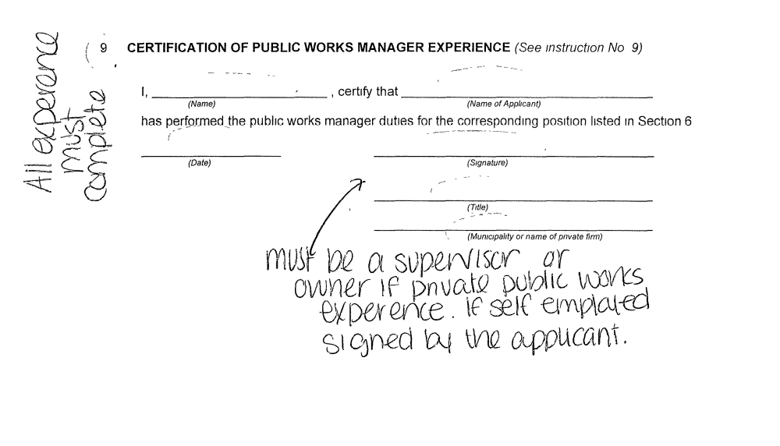

CPWM Initial Application
Instructions for Completing and Filing
APPLICATION FOR A CERTIFIED PUBLIC WORKS MANAGER CERTIFICATE

WHO MAY FILE AN APPLICATION
- Any person who satisfies the requirements listed below may file an application for the certification exam:
  - Applicant must be at least 21 years of age;
  - Applicant must be of good moral character,
  - Applicant must have obtained a certificate or diploma issued after at least four years of study at an approved secondary school or have received an academic education considered and accepted by the Commissioner of Education as fully equivalent,
  - Applicant must have completed the Rutgers University Certified Public Works Manager Program. Include a copy of diploma with application
  - Applicant must meet the definition of a public works manager as defined in paragraph 5 below
OR
- Applicant will be exempt from the certification exam if they meet the above requirements and either of the following criteria.
  - Applicant has a bachelor or greater degree m civil or related public works engineering and is licensed professional engineer in the State of New Jersey. An applicant who meets this requirement is not required to complete the Rutgers program noted in 1.d. above. The application must include a copy of the college diploma and/or transcripts, and a copy of the engineer's license.
  - Applicant completed the Rutgers program prior to August 13, 1994. The application must include a copy of the diploma.
DEFINITIONS
- "Management responsibility" means the supervisory responsibility for planning, scheduling, directing, controlling and coordinating the daily and long-term operations of public works activities, as applicable, including the utilization of manpower, equipment, materials, funds, and other available resources
- "Public works activity" means maintenance of streets, drainage, public buildings and places, water and wastewater, solid waste, motor vehicles, or similar items related to the physical plant and infrastructure of a municipality. Work for a municipal utilities authority shall not be considered a public works activity.
- "Public works manager" means a person who in at least 5 or the last 1o years, has served in a position of public or private public works, construction management or a civil engineering position where no less than fifty percent of the person's work time was directly spent in daily, direct supervision of public works activities.
HOW TO FILE
One copy of the application must be completed and signed. All questions must be answered fully A check or money order in the sum of $50 payable to the "Treasure, State of New Jersey" must be attached; do not send cash. Necessary proofs must be attached. An application shall not be deemed to be filed unless the form is properly completed and the fee and proofs attached. This application must be filed with the Division of Local Government Services not less than thirty (30) days prior to the announced date of the examination. Send application to:
NEW JERSY DEPARTMENT OF COMMUNITY AFFAIRS DIVISION OF LOCAL GOVERNMENT SERVICES CERTIFCATION UNIT
P.O. BOX 803
TRENTON, NJ 08626-0803
Upon review of the application, the Director of the Division of Local Government Services may require filing additional statements and proofs.

COMPLETING FORM
SECTIONS 1 – 4 - Applicant will supply information relating to age and moral character
Section 5 - Applicant will supply information relating to high school education. Persons desiring information relating to high school equivalency certificates may write to
DEPARTMENT OF EDUCATION DIVISION OF ADULT EDUCATION
GED TESTING
P.O. Box 500
TRENTON, NJ 08625-0500
Section 6 - Applicant will supply information relating to public works experience as described in paragraphs 3, 4 and 5 above
Section 7 - Applicant will designate whether he/she Is applying for partIc1patlon m, or exemption from, the examination Necessary proofs, as noted, must be attached
Section 8 - Municipal Clerk will complete Section 8. Clerk must certify the total years of experience as a public works manager as defined in paragraph 5 above. If experience was obtained m more than one municipality, experience must be certified for each This section need not be completed 1f public works manager experience 1s in the private sector
Section 9 - The manager/admm1strator or other chief admm1strabve office in the municipality, or private firm supervisor, must complete the information certifying that the applicant performed the public works manager duties described in Section 6 If the experience was obtained m more than one municipality or firm, the experience must be certified for each

Revised, August 2014; Typed July 2026

DIVISION OF LOCAL GOVERNMENT SERVICES NOTIFICATION FORM FOR REPEAT PARTICIPANTS CERTIFIED PUBLIC WORKS MANAGER EXAMINATION
If you are a repeat participant for the Certified Public Works Manager Examination, please complete the information below and return to:
Division of Local Government Services
P.O. Box 803
Trenton, New Jersey 08625-0803
Attn Certification Unit
This form is to be accompanied by a check or money order in the amount of $50 made payable to the “State Treasurer.” The fee is not refundable. The form may also be emailed to the attention of the Certification Unit at DLGS.Certification@dca.nj.gov (if emailing, please mail the check or money order separately). If you have any questions in regard to completion of this form, please contact Shannon Hudak at (M") 2€J'z:=99-57. THIS FORM MUST BE MAILED, TELEFAXED, or EMAILED 30 DAYS PRIOR TO THE DATE OF THE EXAMINATION FOR WHICH YOU ARE APPLYING.
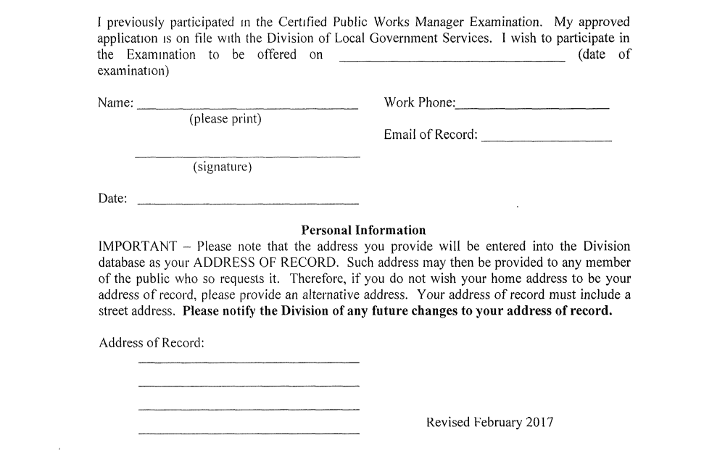

CPWM Renewal Application

CPWM Renewal Application
Local Finance Notice 2026-05 January 29, 2026 Page 3
As before, the audit must be filed with the Division in FAST within five (5) days after being filed with the local unit.
The deadlines for certifying the governing body's review of the audit, along with the corrective action plan, must be filed with the Division within 45 days and 60 days, respectively, of the municipality or county receiving the audit. See Local Finance Notice 2024-10 for further details.
The Director is now authorized to impose a $100 personal daily fine upon an auditor. governing body member, or other local official responsible for noncompliance.
Deadline to Fill Vacancies in Required Positions; Daily Penalty for Failure to Fill Vacancy.
Sections 11, 12, 14, 15, and 17 ·of P.L. 2025, c.185 amend various provisions of law to establish a standard 90-day deadline for filling a vacancy in each of the following required positions:
- Chief county finance officer (CCFO)
- Chief municipal finance officer (CMFO)
- Tax collector
- Municipal clerk
- Principal public works manager (municipality)¹
The local unit's governing body or chief executive officer may make written request to the Director for an extension. The Director may approve an extension upon a showing of good cause and the local unit's demonstrated inability to fill the vacancy despite having made a good faith effort to do so. If governing body members or a chief executive officer, whoever is responsible for making the appointment, fail or refuse to fill the vacancy, the Director is authorized to impose a personal penalty of $100 per day upon such officials until the vacancy is filled.
Below are the permitted means of filling vacancies for each required position upon the departure of a certified official:
Tax collector | - Appointing an individual with a certified tax collector (CTC) certificate  - Shared services agreement with another municipality  - Appointing an individual with a county finance officer certificate
CCFO | - Appointing a non-certified individual on an acting basis  - Shared service agreement with another comity  - Appointing an individual with a municipal finance officer certificate
CMFO | - Appointing a non-certified individual to serve on acting basis  - Shared service agreement with another municipality  - Contracting with a private entity to temporarily fulfill CMFO duties
Municipal Clerk | - Appointing an individual with a registered municipal clerk (RMC) certificate  - Appointing a non-certified individual to serve on an acting basis  - Shared services agreement with another municipality
Principal Public Works Manager | - Appointing an individual with a certified public works manager (CPWM) certificate  - Appointing a non-certified individual to serve on an acting basis
¹ Any municipality that conducts minimal or no public works activity may apply to the Director for an exemption from the requirement to appoint a principal public works manager. If granted, the exemption shall be valid for five years from the date of issuance, at which time the municipality must either reapply for an exemption or select a person to perform the duties of a principal public works manager.
Please review this section in conjunction with Local Finance Notice 2018-03R.
Director Review of DLGS-Certified Officials
Sections 13, 16, 17 and 19 of P.L. 2025, c. 185 affirm the Director's ability to review the behavior or practices of individuals holding a CTC, RMC, CPWM, or Qualified Purchasing Agent (QPA) certificate. The Director may suspend or revoke certifications awarded by the Division for dishonest practices, or willful or intentional failure, neglect, or refusal to comply with the State constitution, laws and regulations pertaining to their duties and functions, or other good cause.
Director Approval for Mailing Estimated Property Tax Bills after Statutory Deadline
Starting with 2026 tax bills, the governing body of a calendar year municipality may adopt a resolution seeking Director approval to mail estimated tax bills after the June 30 deadline established by N.J.S.A. 54:4-66.3. If the municipality demonstrates good cause, the Director may approve the application subject to appropriate terms and conditions. The Director's determination shall be final. The deadline for mailing reconciled bills remains September 30.
Using the same process, State Fiscal Year municipalities may also seek Director approval to mail estimated tax bills after December 31 (first installment) and June 30 (third installment). The deadline to mail reconciled tax bills for the second and fourth installments remains March 31 and September 30, respectively.
The governing body resolution requesting an extension shall be submitted via email to DLGS@dca.nj.gov with the heading titled "Post-Deadline Estimated Tax Bills."
No Mailing of FAST-Submitted Documents to Division
Any documents required to be submitted through the Financial Automation Submission Tracking (FAST) system shall not be sent to the Division via regular mail or e-mail. The Division will not accept mailed or e-mailed documents that must be submitted through FAST.
Approved: Michael F. Rogers, Director
Document | Internet Address
P.L. 2025, c.185 | https://2ub.njleg.state.nj.us/Bills/2024/A5500/5240·RI.PDF
LFN2024-10 | https://www.nj.gov/dca/dlgs/lfns/2024/2024-10.2df
LFN 2018-03R | https://www.nj.gov/dca/dlgs/lfns/2018/2018-03R.pdf

Regular Appointment Terms
Position: | Appointment Term: | Statute:
Principal Public Works Manager (CWPM) (By statute, must be filled by a CPWM). | We do not have a recommendation. | None
Qualified Purchasing Agent (QPA) | Not set by statute, based on the  discretion of the governing body. The  suggested term is 1 year. | None
Registered Municipal Clerk (RMC) | Does not complete the unexpired term.  Full term is for 3 years from date of appointment. | N.J.S.J.A, 40A:9-133a
¹The PPWM doesn’t have to be the DPW Director/ Super, Forman, etc. If the individual holding the CPWM is in a position to advise the governing body (engineer common).
Tenure - Who gets it & how?
Position: | Tenure Requirements: | Statute:
Qualified Purchasing Agent (QPA) | Does not receive tenure | None
Registered Municipal Clerk (RMC) | Complete a full 3-year term and be reappointed. | N.J.S.A.  40A:9-133.7.b
Principal Public Works Manager (CWPM) | The governing body can grant | ''N.JS.A.  40A:9-145

